Kyiv College of Communications

Cycle Commission of Computer Engineering

**PERFORMANCE REPORT**

**WORK-CASE №2**

*in discipline: "Operating systems"*

*Topic: "Linux commands for archiving and compressing data"*

Performed by students

RPZ-93A group

Makarenko Danylo

Nemechkin Maxim

The teacher checked

Povkhlib V.S.

Kyiv 2021

In this Work-case, we installed a type II hypervisor on our home workstation and created a new virtual machine. Selected equipment available for the virtual machine, set up a network and connected to a Wi-Fi hotspot, also connected the ability to work with external media (flash memory). We installed the Linux CentOS operating system in the basic configuration with a graphical shell in our hypervisor.

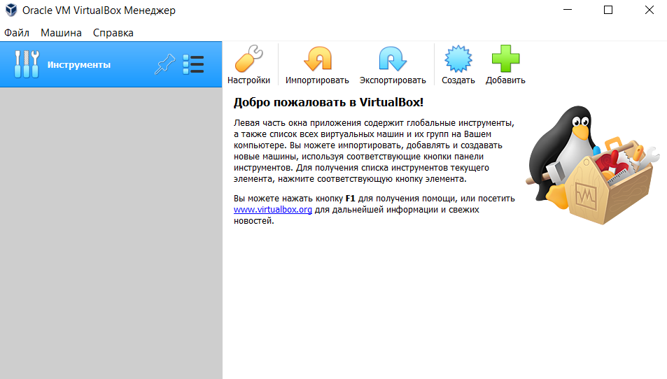

1) Creating a new virtual machine goes through "Machine" - "Create".

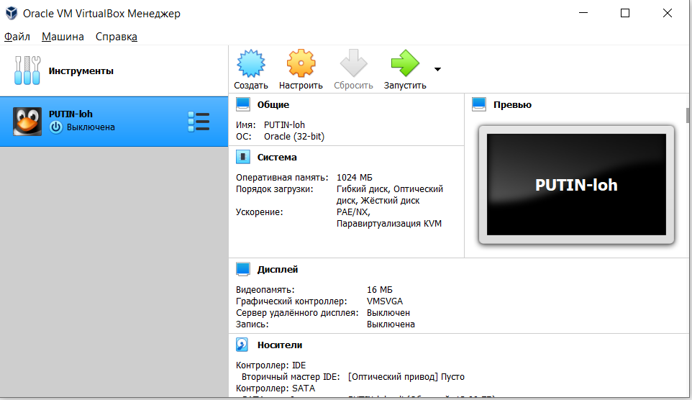

2) Available equipment and other settings can be found in the "Settings" item.

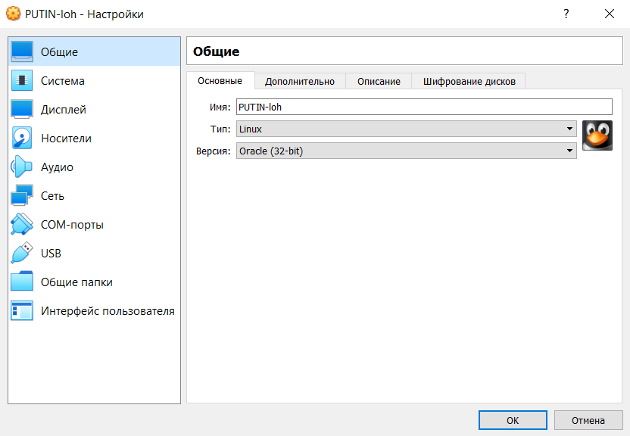

3) Connection to WiFi and network settings is also in the "Settings" - "Network".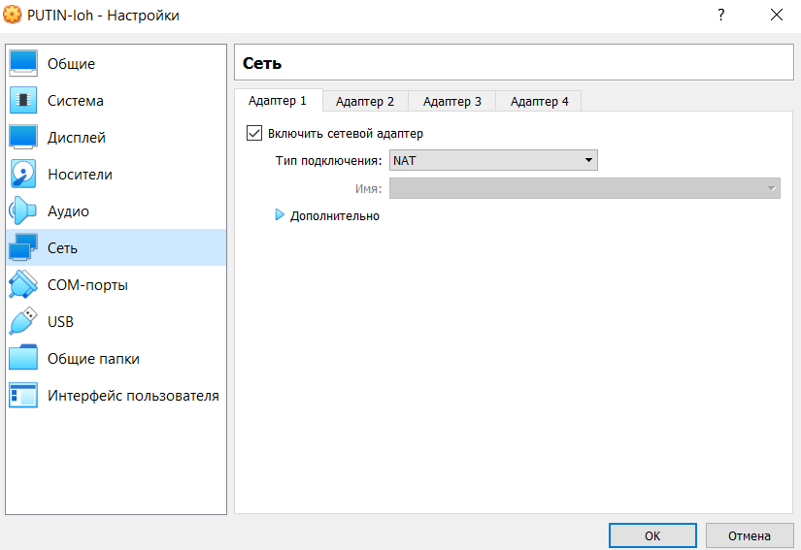»

4) External media is "Settings" - "USB".

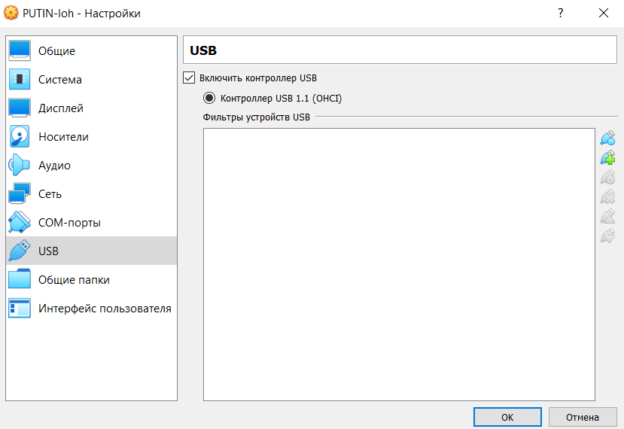

5) This is what the desktop looks like.

